**Required programs:**

* WAMP (MAMP) Server or equivalent: http://www.wampserver.com/en/
* Internet Browser. (Eg: Google Chrome)

**Step 1:**

Transfer all the files into the WAMP or MAMP server root folder. Ensuring that the index.html file and other files are not in any other sub-folders and are directly in the 'www' folder.

Usually located here after the install: C:\wamp\www

See below:

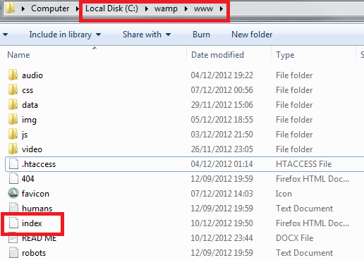

**Step 2:**

Ensure the WAMP server icon is green in the icon tray.

**Step 3:**

Open browser and type into the URL bar: localhost

**Step 4:**

Website should load, browse away!